# Program code for drawing ellipse

#include<stdio.h>

#include<conio.h> #include<graphics.h> void main()

{

int gd=DETECT,gm; initgraph(&gd,&gm,"C:\\TURBOC3\\BGI"); int xc=300,yc=200,rx,ry; float p1,p2,x,y; printf("Enter radius xc and yc"); scanf("%d%d",&rx,&ry); x=0; y=ry; p1=(ry*ry)-(rx*rx*ry)+((rx*rx)/4); while((2*ry*ry*x)<=(2*rx*rx*y))

{ if(p1<0){ x++; p1=p1+(2*ry*ry*x)+(ry*ry);

} else{ x++;

y--;

p1=p1+(2*ry*ry*x)-(2*rx*rx*y)+(ry*ry);

} putpixel(xc+x,yc+y,WHITE); putpixel(xc-x,yc+y,WHITE); putpixel(xc+x,yc-y,WHITE); putpixel(xc-x,yc-y,WHITE);

} while(y!=0) { if(p2<0){ x++;

y--;

p2=p2+(2*ry*ry*x)-(2*rx*rx*y)+(rx*rx);

} else{ y--;

p2=p2-(2*rx*rx*y)+(rx*rx);

} putpixel(xc+x,yc+y,WHITE); putpixel(xc-x,yc+y,WHITE); putpixel(xc+x,yc-y,WHITE); putpixel(xc-x,yc-y,WHITE);

} getch(); closegraph();

}

**Output**

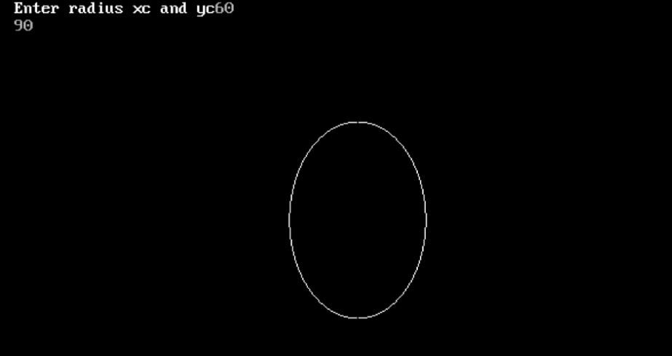

# Discussion

In this lab, we learnt how to draw an ellipse using mid-point algorithm. We wrote a program in C language to draw the ellipse.

# Conclusion

Hence, we studied about mid-point ellipse algorithm.